|  |  |
| --- | --- |
| **TDD** | |
|  | |
| **Documents Control Section** | |
|  | |
| **Tracker Details** | |
| **About the Document** | **Technical Design Document (**[**TDD**](https://teams.microsoft.com/l/file/0E3A50F7-E1FF-4056-9538-F2A343BE535D?tenantId=76a2ae5a-9f00-4f6b-95ed-5d33d77c4d61&fileType=docx&objectUrl=https%3A%2F%2Fcapgemini.sharepoint.com%2Fsites%2FDACAutomation%2FShared%20Documents%2FTemplates%2FSOP.docx&baseUrl=https%3A%2F%2Fcapgemini.sharepoint.com%2Fsites%2FDACAutomation&serviceName=teams&threadId=19:8c58737e2e9140bb824a7f1b1e4d89b7@thread.skype&groupId=0bd96114-4d89-4a8e-b7ca-768be1fa8750)**) is a development solution document updated by the Development Team given by DAC Solution Architect Team.** |
|
| **Author** | **Development Team** |
|
| **Data Owner** | **Development Team** |
|
| **Audience** | **All DAC Automation Associates** |
|
| **Data Classification** | **Company Confidential** |
|

|  |  |  |  |  |  |  |  |  |
| --- | --- | --- | --- | --- | --- | --- | --- | --- |
| **Template Revision History** | | | | | | | | |
|  |  |  | |  |  |  |  |  |
| **Version** | **Date** | **Author** | **Brief Description of Changes** | | | | **Approver Signature** | |
| 1.0 | 12-Oct-2022 | Shravani Mukka | Initial Draft | | | |  | |
|  |  |  | |  |  |  |  |  |

     Disclaimer: Below formats needs to be followed across all the tracker.

|  |  |
| --- | --- |
| **Name** | Shravani Mukka |
| **Date** | 12/10/2022 |
| **Rate** | $ |
| **Time** | Hrs-Min-Sec AM/PM |

EXCEL TO PPT

|  |  |
| --- | --- |
| Account Name | Utility |
| Catalog Id |  |
| Effective Date | 12-10-2022 |
| Version Number | 1.0 |
| Revision Date |  |

Contents

1. Document Control 4

2. Introduction: 5

3. Scope: 6

4. Process: 7

5. Flowchart: 11

# Document Control

|  |  |  |  |
| --- | --- | --- | --- |
| Revision History: | | | |
| Version: | Date: | Author(s): | Description: |
| 1.0 | 12-Oct-2022 | Shravani Mukka | Initial version |
|  |  |  |  |
|  |  |  |  |

|  |  |  |  |
| --- | --- | --- | --- |
| Manager Reviews and Approval: | | | |
| Date | Version | Team | Comments |
|  |  |  |  |

# Introduction:

Main theme of this utility is used to convert excel detailed format into a Power Point Slide based on the cell values. This utility is built using Macros VBA code. A sample PPT path is given as input to the VBA code, based on the input the excel values are arranged into the PPT slide.

# Scope:

Conversion of excel values to the power point presentation, which is useful to present to the end customers or clients.

# Process:

1. In the excel, we can see developer tab as shown in the below image. Under the developer tab, click on view code. Once you click on view code, Macros code editor is opened where we can write the code and execute it.

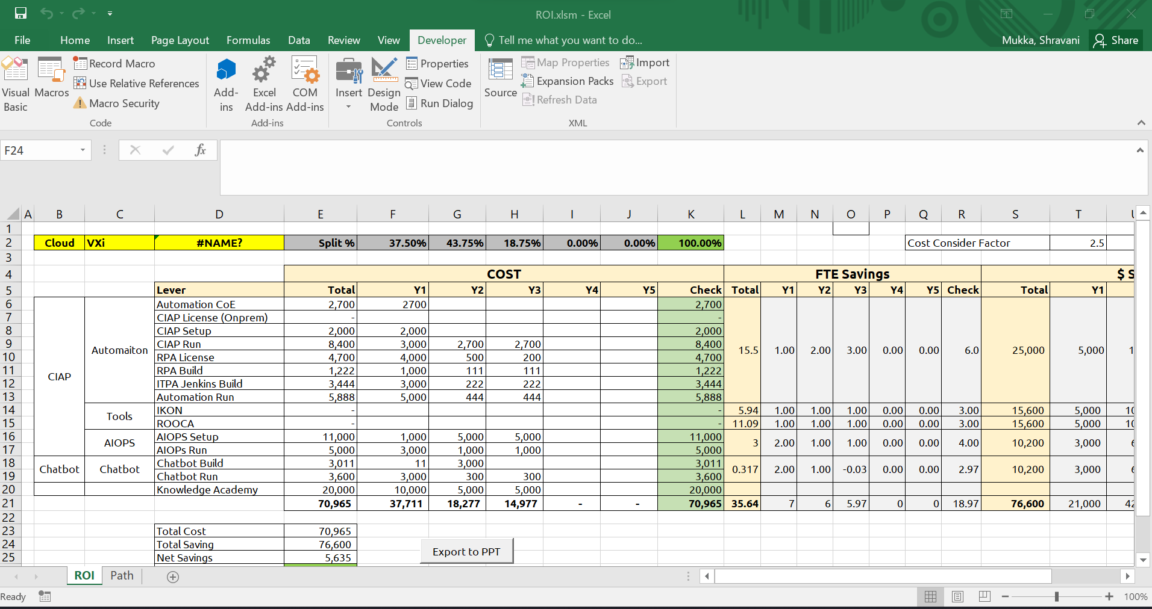

1. Below is the image of the excel code, CommandButton1_Click() is the action to the Excel to PPT button.
2. CustomFormat() is the function which will perform the calculation of total savings and net savings.
3. getNumberText() is the function which rounds the values of net savings and total savings with ‘M’ if the values is in 100’s and ‘K’ if the value is in 1000’s.
4. CommandButton1_Click() is the main action to the button which takes the input as sample power point slide and puts all the values from excel to PPT. Rounds the total and net savings values with function call and saves the PPT in the output file location.

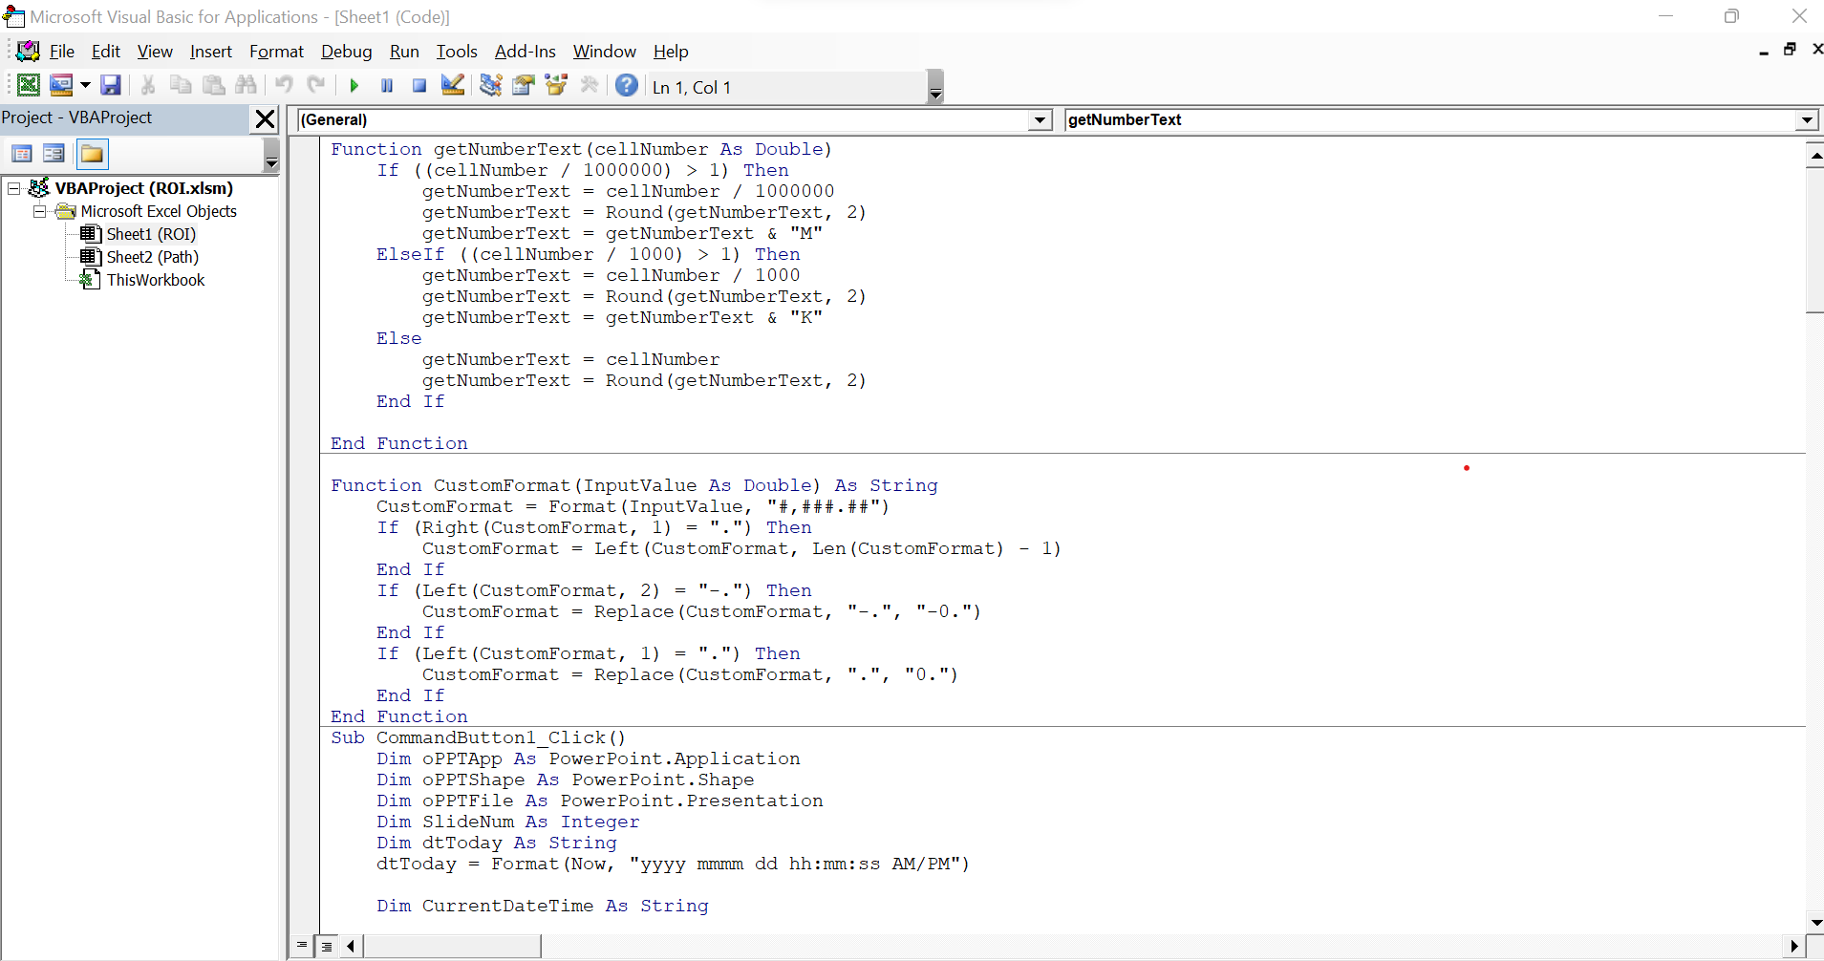

1. Excel has 2 sheets, ROI sheet consists of data converted to be PPT. Path sheet has the input, output paths. Input path is the path of the sample PPT Slide. Output path is the location where the ppt generated is saved with PPT name concatenated with date and time.

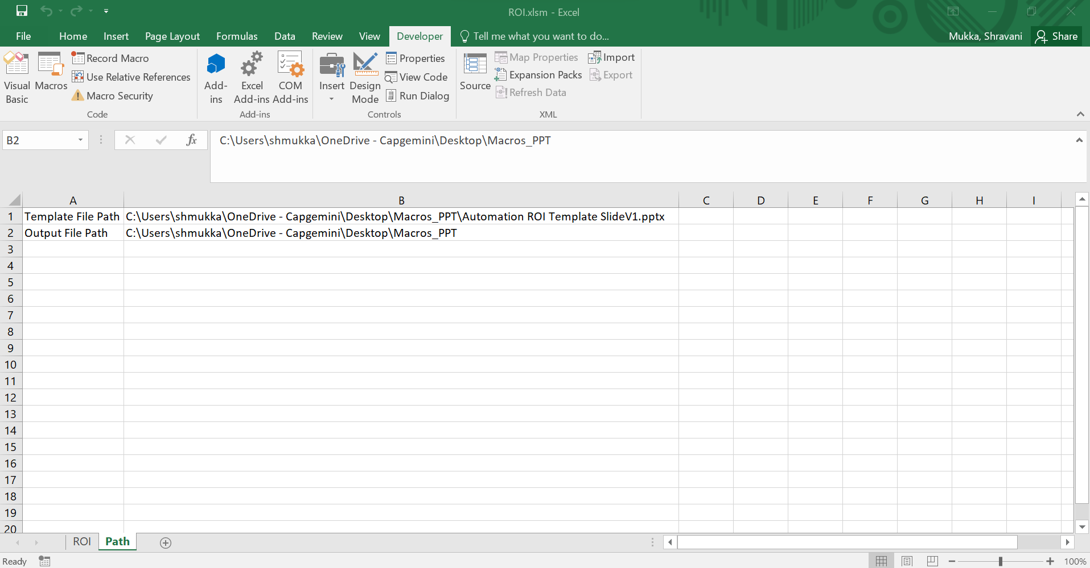

1. Below is the image of sample PPT Slide.

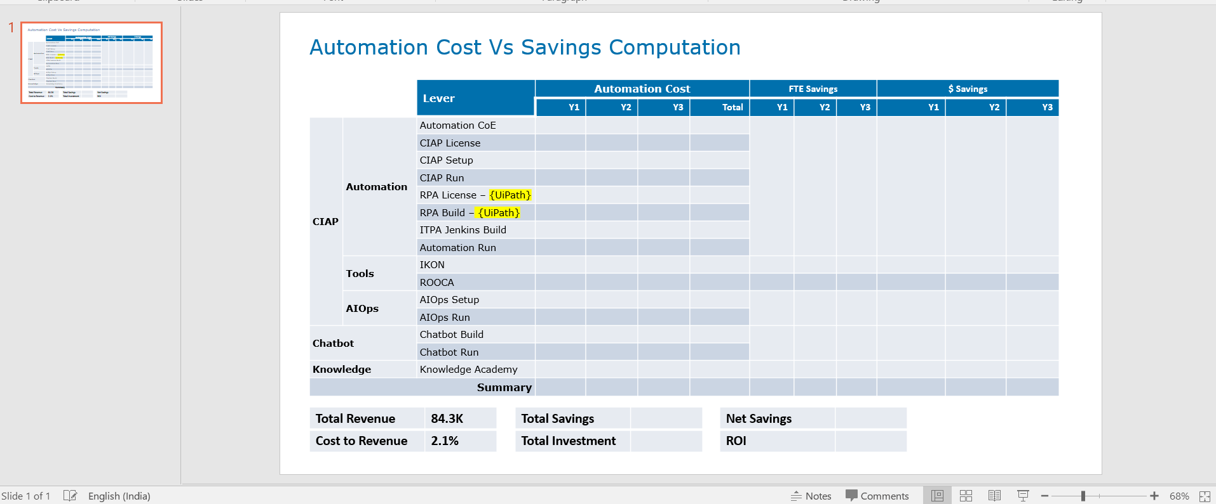

1. The excel consists of a button named “ExcelToPPT” is a command button. Once users clicks on this button, macros code is executed and PPT slide is generated.

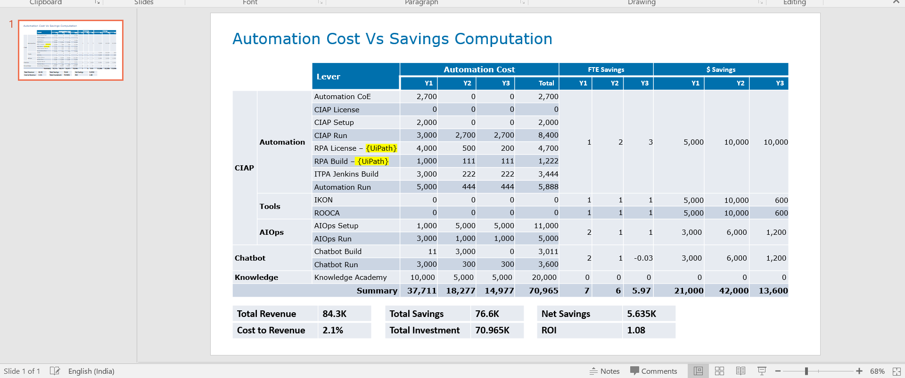

1. The PPT is generated and saved in the output location with the PPT name followed by date and time as shown below.

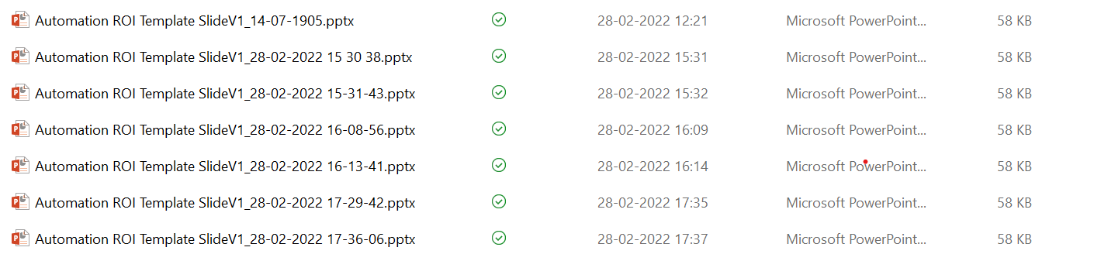

1. Input PPT for reference



1. Output file for reference



1. Macros excel for reference



# Flowchart:

